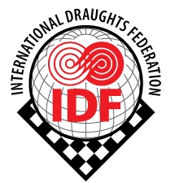 | INTERNATIONAL DRAUGHTS FEDERATION  Member of TAFISA
Dobrich Region, Municipality Balchik, Kranevo, Chernomorska str. 41, 9649 Bulgaria, UIC 176513387
tel.+79219562001, e-mail: office@idf64.org, vlangin@yandex.ru, nikiforov@idf64.org

No 4 from 15-01-2015 to all Draughts Federations

International Draughts Federation (IDF) in accordance with the Calendar of the competitions in 2016 holds European Youth Championship in draughts-64.
Place, date
Championship will be held at the hotel "Okhtinskaya", Bolsheokhtinsky prospekt 4, St. Petersburg, Russia, from April 20 (arrival day) to April 29 (departure day), 2016.
Credentials Committee will work April 20 from 14.00 till 22.00.
All participants must have medical insurance for the period of competition.
Participants who did not pass the Credentials Committee to 22.00 participate in the additional draw which will be held April 21 at 12.30. These participants pay an additional fee 20 Euro.
Tournament regulations
Championship is held separately for boys and girls in six age groups:
Juniors born in 1993-1996;
Juniors born in 1997-1999;
Cadets born in 2000-2002;
Junior cadets born in 2003-2005;
Hopes born in 2006-2007;
Junior hopes born in 2008 and later.
Boys and girls of younger ages may participate in age groups 1993-1996; 1997-1999; 2000-2002; 2003-2005, 2006-2007.
Championship is held in the three types of programs:
Classic game - with time control 45 minutes till the end of the game + 10 seconds per move;
Rapid game - with time control 07 minutes till the end of the game + 05 seconds per move;
Blitz game - with time control 03 minutes till the end of the game + 02 seconds per move.
System of competition is Swiss or round robin, depending on the number of participants.
All programs are held in Russian version of draughts-64 by the system of micro-matches consist of two games.
In age group juniors born in 1993-1996 draw of the moves according to the official tables is held for boys and draw of the first move of the white is held for girls.
In age groups juniors born in 1997-1999 and cadets born in 2000-2002 draw of the first move of the white is held for boys and girls. Draw is binding on both games of the micro-match.
In other age groups draw of the moves is not held.
Team’s classifications are determined in classic program of Championship.
Team places are defined by the maximum amount of points scored 8 best players (by one from age group 1997-1999; 2000-2002; 2003-2005, 2006-2007 for boys and girls).
Team’s classifications are determined also separately for boys and girls teams by the maximum amounts of points scored 4 best players (by one from age group 1997-1999; 2000-2002; 2003-2005, 2006-2007 for boys or for girls).
Requirements for participants
Winners of European Youth Championship-2015, participants claimed by national federations are allowed to participate in competition.
Participants must comply with the dress code.
Participants must to be on the opening and closing ceremony of the competition. In case of absence the closing ceremony, participants lose all official awards. Awards will not be sent or transferred.
Awards
Medals for the 3 first places in each tournament;
Cups for the 3 first places in each tournament;
Diploma for the 3 first places in each tournament;
Diploma for all participants in classic program;
Cups for the 3 first places in the overall team’s classification;
Diploma for teams and participants of the teams took 3 first places in each team’s classification;
Personal awards for winners of Championship in all age groups will be announced by organizers at the opening ceremony.
Tournament fees
Each participant before the start of competition should pay tournament fee.
In age group 1993-1996:
40 euros for classic program;
20 euros for blitz;
20 euros for rapid;
In age groups 1997-1999; 2000-2002; 2003-2005, 2006-2007:
For three representatives of each country in every age group among boys and girls –
40 euros for the classic program;
20 euros for blitz;
20 euros for rapid;
For other representatives of each country:
60 euros for classic program;
30 euros for blitz;
30 euros for rapid;
In age group 2008 and younger:
30 euros for classic program;
15 euros for blitz;
15 euros for rapid
Tournament fees may to be transferred to the account of the International Draughts Federation no later than April 10 or pay in cash to the credentials committee not later than April 20. In case of bank transfer payment receipt must be presented to the credentials committee.
Bank details
Beneficary: International Draughts Federation
Address: Kranevo, Chernomorska str. 41, 9649 Bulgaria
Bank: Raiffeisenbank (Bulgaria) EAD
Bank`s address: Dobrich, 25 Septemvri Str. 25, 9300 Bulgaria
IBAN account no: IBAN BG94 RZBB 9155 1003 8766 00
BIC (Swift code): BIC RZBBBGSF
Accommodation and meals
Hotel accommodation is in 2-3 bed rooms with facilities in the room. Rooms will be booked in the order of receipt of applications.
All participants, coaches and accompanying must residence in the hotel "Okhtinskaya" from April 20 to April 29.
In case of violation of this paragraph penalties can be applied.
The organizers provide accommodation and three-time meals for one player (boy or girl) from age group 1997-1999; 2000-2002; 2003-2005, 2006-2007 (4 participants total) from April 20 (starting with lunch) to April 29 (ending with breakfast) from each country - member of the International Draughts Federation (IDF).
Their travel costs, as well as the costs of accommodation, meals and travel of other participants pays by their sending organizations.
Participants who provide accommodation and meals by organizers are required to participate in all three programs: classic, rapid and blitz.

The cost of accommodation and three-time meals for all other participants and accompanying:
Double "standard" + three meals a day 1700 rubles / person
Triple "standard" + three meals a day 1600 rubles / person
Double "business" + three meals a day 1900 rubles / person
If necessary, price per single room is:
Single "standard" + three meals a day 2150 rubles / person
Single "business" + three meals a day 2650 rubles / person
For foreign citizens (including Belarus) requires registration. Price is 150 rubles / person
Travel
From the hotel to the Plaza Vosstania runs a free shuttle. Around the hotel is a stop of public transport. The nearest metro stations are "Novocherkasskaya", "Chernyshevskaya", "Ladoga" - 10 minutes to the hotel by public transport.
Schedule
 | Date | Day of the week | Time | Event
 | April 20 | Wednesday | 12.00 – 22.00 | Arrival day
 |  |  | 14.00 – 22.00 | Registration of participants
 |  |  | 22.00 | Draw
 | April 21 | Thursday | 12.00 | Opening ceremony
 |  |  | 15.00 | Blitz
 | April 22 | Friday | 10.00 | Rapid
 |  |  | 15.00 | Rapid
 | April 23 | Saturday | 10.00 | Round 1, classic program
 |  |  | 15.00 | Bus excursion
 | April 24 | Sunday | 10.00 | Round 2
 |  |  | 15.00 | Round 3
 | April 25 | Monday | 10.00 | Round 4
 |  |  | 15.00 | Round 5
 | April 26 | Tuesday | 10.00 | Round 6
 | April 27 | Wednesday | 10.00 | Round 7
 |  |  | 15.00 | Round 8
 | April 28 | Thursday | 10.00 | Round 9
 |  |  | 21.00 | Closing ceremony
 | April 29 | Friday | From 9.00 | Departure of participants
The schedule may be changed. In this case, the date and time of registration, opening and closing are final.

Applications
Applications for participation in the Championship must be submitted to the office of International Draughts Federation only from national Federations not later than April 6 on e-mail: office@idf64.org, vlangin@yandex.ru.

Applications for obtaining visas (up to March 31) and booking accommodation (up to April 9) must be submitted to Langina Antonina, tel. +7 921 7777231, e-mail: office@idf64.org, vlangin@yandex.ru. Application form published on the site.
President  International Draughts Federation (IDF) | 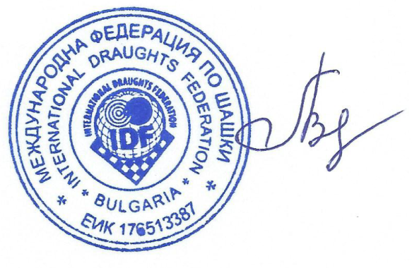 | Vladimir Langin

